**Inbox**By Gmail

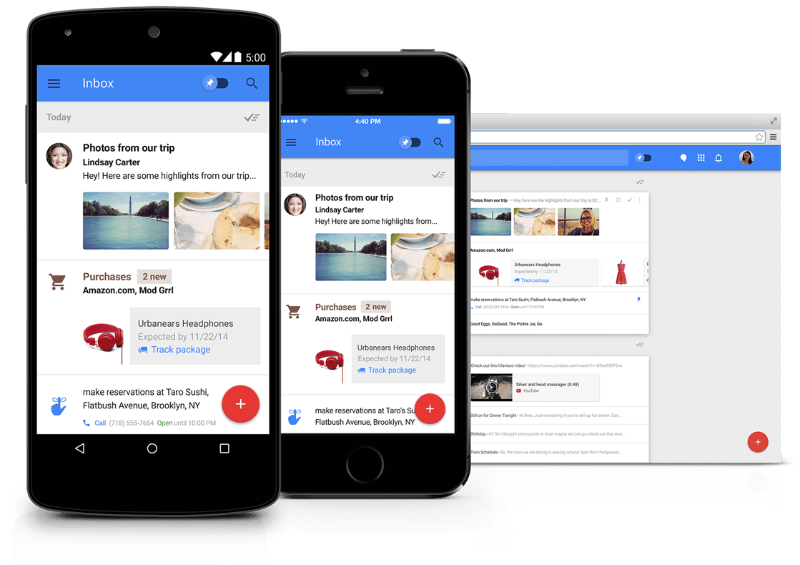

**Assignment:** Usability Test Plan

**Course:** H543 Interaction Design Methods

**Team 4:** Melissa McShea, Neha Singhal, Prachi Kate, Pankaj Avhad, Onkar Borgaonkar

Fall 2015

**Table of Contents**

-------------------------------------------------------------------------------------------------------------------------------

1. Executive Summary

2. Methodology

2.1 Scenario:

2.2 Expert Review

2.3 Participant Profile

2.4 Technology

3. Key Findings And Recommendations

3.1 Task 1: Explore Google Inbox

3.1.1 Issue 1: Inconstant vertical scroll bar

3.1.2 Issue 2: Inefficient organization of information.

3.2 Task 2: Compose Email

3.2.1 Issue 1: Formatting options not available

3.2.2 Issue 2: Options for “Carbon Copy” and “Blind Carbon Copy” are not intuitive.

3.3 Task 3: Respond to an email

3.3.1 Issue 1: Forward button not noticeable

3.3.2 Issue 2: Inconsistent button size

3.4 Task 4 : Grouping the emails into categories (Bundles)

3.4.1 Issue 1: Multiselect for mails not evident

3.4.2 Issue 2: Confusion between ‘Bundled’ and ‘Unbundled’

3.4.3 Issue 3: Confusing nomenclature

3.5.4 Issue 4: Misleading display prompts

3.5 Task 5: Set a reminder on email

3.5.1 Issue 1: Reminder confused with snoozed

3.5.2 Issue 2: Customizing reminder is confusing

3.5.3 Issue 3: No option to add new reminder on reminder page

3.5.4 Issue 4: The reminder feature does not give date and time

Issue 5

3.6 Quantitative Results

4. Conclusion

5. Appendices

5.1 System Usability Scale

5.2 Informed Consent Form

5.3 Usability Test Plan

Participant Welcome and introduction

Background

Scenario

Task List

Facilitator Script

1. View your email Inbox

2. Compose an Email

3. Respond to an Email

4. Explore how to group mails into a category.

5. Create a customized category called ‘Family’

Explore how to set reminder for an event

5.4 Interview sessions

# **1.Executive Summary**

----------------------------------------------------------------------------------------------------------------

Inbox by Gmail is an app built on the top of existing Gmail application, aimed to enhance the productivity and organization of emails through several new features including snooze messages to read later, group similar emails, and explore email with Google cards for flight times. The application works on Android, iOS, and browsers like Chrome, Firefox, and Safari.

Our team of graduate students from Indiana University School of Informatics in Indianapolis began with an expert review to evaluate Inbox. Based on the initial findings from the expert review, a usability test was conducted which consisted of users completing a variety of tasks on both the website and mobile application. The tasks were planned around the main functions of Inbox such as explore the product, compose an email, respond to an email, create bundles, and set reminders from the application.

Each participant was asked for a post-task comfort rating of that task along with the pre-test and post-test questionnaire to collect demographic data and assess the overall usability of Inbox - SUS score. We randomized the order of mobile and web-based platforms and asked users to perform the tasks on both of them one after the other. The fascinating thing about Google Inbox that we observed was, the participants performance improved after they were able to get familiar with the product. This is observed through the time taken to perform the tasks on the first platform being significantly more than the second platform. e.g. if the user performs the tasks on the web based Inbox for 40 minutes, then they take only 20 minutes to complete it on mobile. Although participants found consistent user experiences across the web and mobile application, they felt more comfortable on mobile. SUS score unveils comfort level on mobile (61.25) vs. desktop (59).

Overall icons for the new feature were confusing for the user as they lack understanding about meaning and use of operation. Participants noticed the pin icon but confused as what it does and why it looks like the on-off switch. More than ninety percent users could not figure out the tick mark icon, and what it does. Most of our participants were first time users of the Inbox, and they tried relating everything with the classical Gmail application. The feedback for every action appeared at the bottom was not prominent. However quick reply and compose email option were easy as they are compatible with classical Gmail. It was found that users struggled with bundling feature as they expected to create and apply the rule on existing emails. Also, they did not find "Select all" option for selecting emails. Snooze on message was a relatively new concept for most of the participants, and they struggled with creating reminders. Poor icons and a learning curves indicate difficulty in handling the application, poor user experience, and scope for redesign and improvement.

# **2.** **Methodology**

----------------------------------------------------------------------------------------------------------------

## **2.1** **Scenario**:

As a student Emily is a busy person preparing for professional life and her studies. She uses her google email account to manage email contacts efficiently. She needs to check her google email account for potential internship interviews (to apply and to check status of interviews) and looks out for coupon codes for interview outfits and potential personal life offers.

## **2.2 Expert Review**

We conducted a rapid expert review on the Google Inbox app both on mobile as well as desktop.

We tried to complete ordinary email tasks, learn the app’s new features, and transition from the mobile app to the desktop app.

1. A general absence of font hierarchy makes the concept of bundles difficult to understand. We found it difficult to understand which is the important content and where to focus

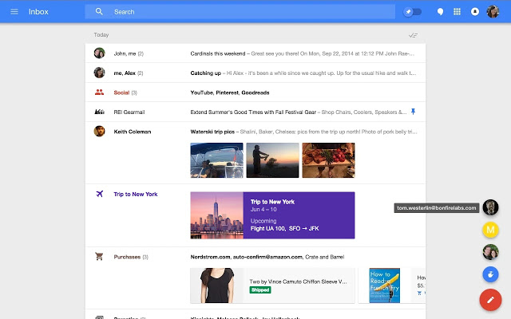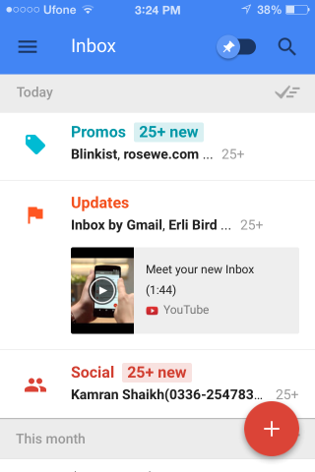

2. We found that there were more interactions available for convenience of users on smartphones than on desktops

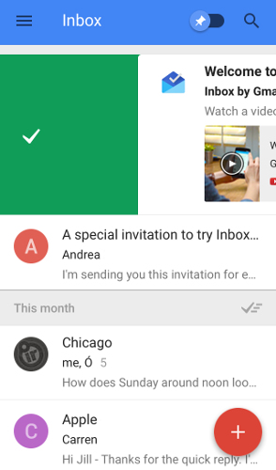

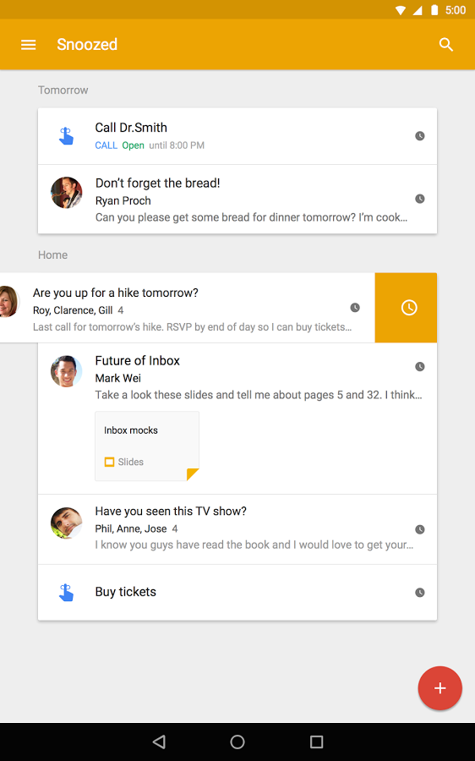

3. We found that there was no information as to what time the email was received even if it is categorized under Today, Yesterday etc.



4. The use of “mark done” concept was not clear and confused the user when on click of the icon on the the mail clicked just disappeared.

Desktop has a hover on mark done feature Users are clueless on Mobile

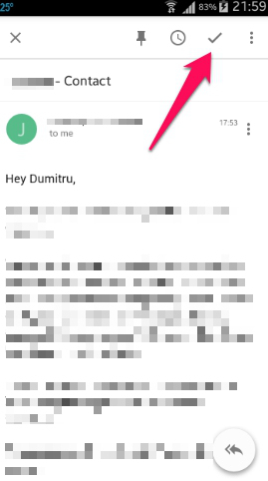

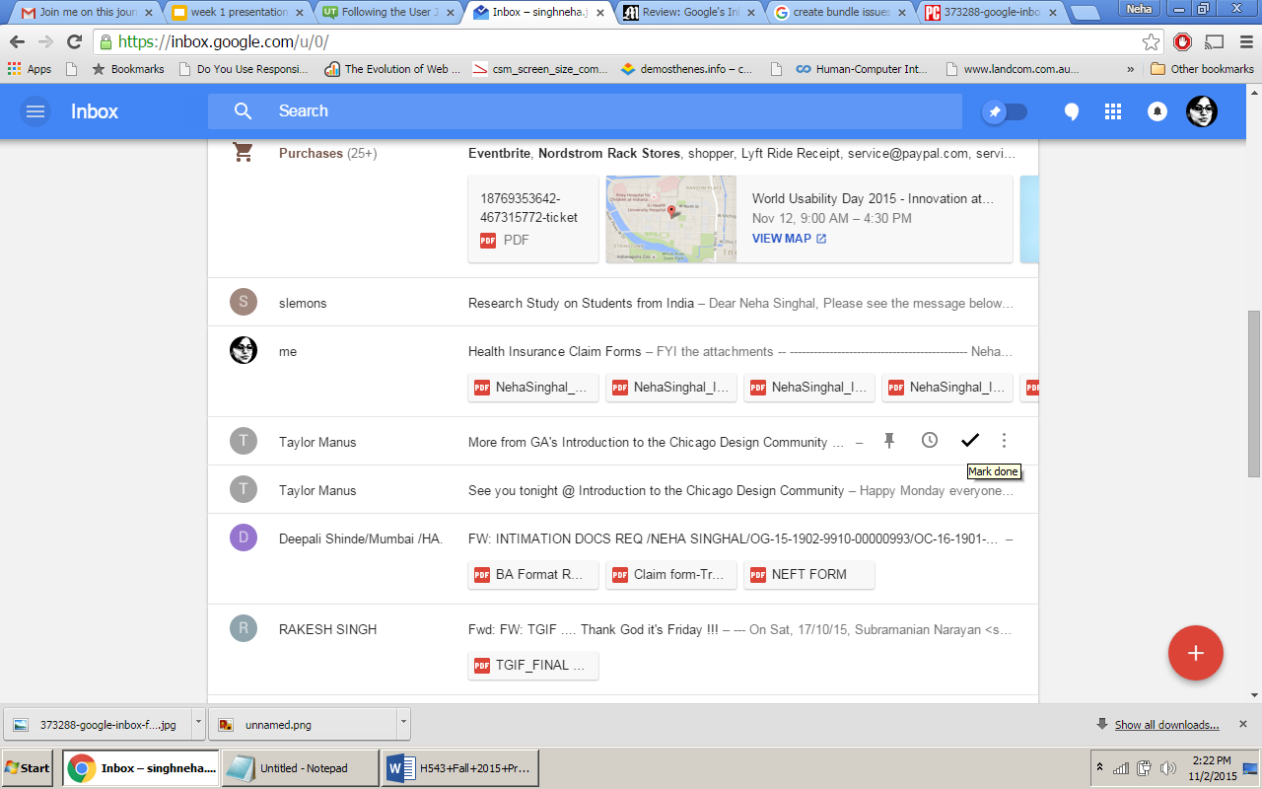

5. The intent of using the plus button is unclear.The options inside the plus button do not relate to the icon used. Users tend to click back on the plus button to close it but then it turns out that it closes on hover.

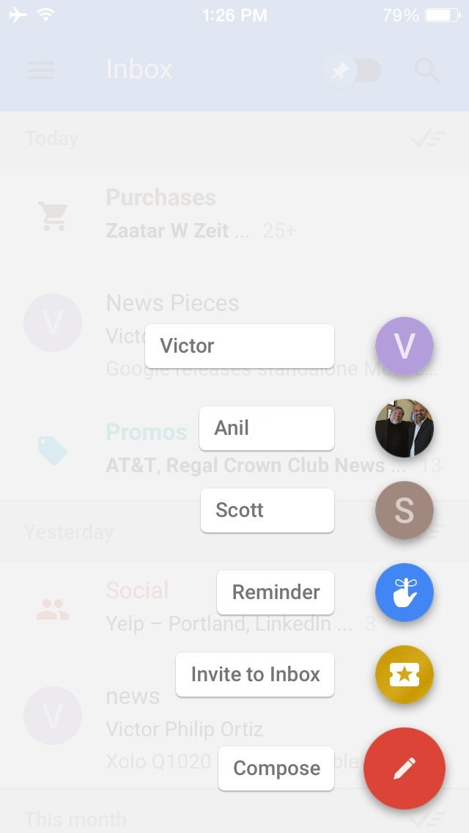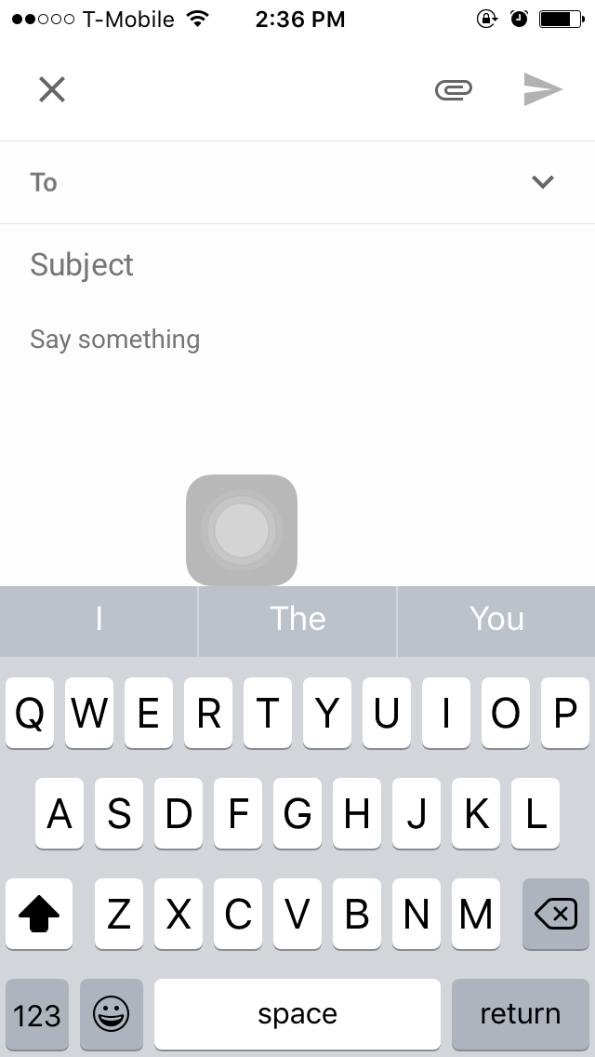

## **2.3 Participant Profile**

|  |  |  |  |  |  |  |  |  |  |  |  |
| --- | --- | --- | --- | --- | --- | --- | --- | --- | --- | --- | --- |
| User demographics | Shilpa | Rakesh | Mohit | Deepa | Ashwini | Prasad | Shivin | Swapnil | Asa | Yhareli | Avg |
| Age: | 25 | 28 | 27 | 23 | 26 | 23 | 25 | 22 | 29 | 24 | 25.2 |
| Profession | Student | health informatics | Soft. Engineer | Student | Soft. Engineer | Student | UX designer | Student | Student | Student |  |
| No of hours spent using mails per day | 16 | 6 | 2 | 10 | 7 | 1 | 2 | 1 | 7 | 12 | 6.4 |
| Location | UITS | UITS | Participants home | Grad Lab | Participants home | Participants home | Participants home | Participants home | UITS | UITS |  |

## **2.4 Technology**

Audio and Screen recorder (Screencastify, ScreenCast-android, Xmirage-Iphone), Survey Questionnaire, Notes

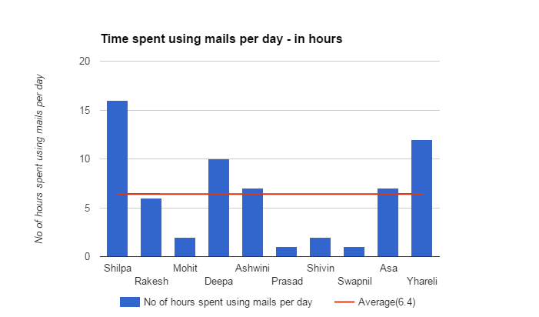

# 

# 

# 

# 

# 

# 

# 

# 

# 

# **3. Key Findings And Recommendations**

----------------------------------------------------------------------------------------------------------------

## **3.1 Task 1: Explore Google Inbox**

### **3.1.1 Issue 1:** Inconstant vertical scroll bar

**Explanation:** Vertical scroll bar is not constant for the hamburger menu. When the user expands the hamburger menu and remains on the menu the vertical scrollbar is visible to the user. The scroll bar vanishes when the user moves control from hamburger menu to main Inbox giving an impression of a short hamburger menu.

**Desktop**

|  |
| --- |
| googleinbxo2.png |

**Platform:** Desktop

**Severity ratings:** Medium

**User Quotes:** “Does it even have a scroll bar? I didn't notice it as it’s so cramped up between the main Inbox and the collapsed”

**Recommendations:** Keep the vertical scroll bar for hamburger menu constant when the user is in that area. This would give more clarity to the users regarding additional options available in hamburger menu and users would not feel lost with further steps to be taken.

**Desktop**

|  |
| --- |
| googleinbxo2.png |

### **3.1.2 Issue 2:** Inefficient organization of information.

**Explanation:** All bundles created are displayed under hamburger menu. The bundle is shown at the top of Inbox when a new mail arrives in the bundle. Until then the bundle gets missed in the other mails.

**Desktop**

|  |
| --- |
| googleinbxo22.png |

**Mobile**

|  |
| --- |
| googleinbxo2 2.png |

**Platform:** Desktop and Mobile

**Severity ratings:** Medium

**User Quotes:** “I would like to see bundles constantly fixed at one place”

**Recommendations:** Make the bundles constantly fixed at the top of Inbox which would be easy for the users to locate. This will also fulfill the motive of new Inbox platform to keep the mails organized.

**Desktop**

|  |
| --- |
| googleinbxo22.png |

**Mobile**

|  |
| --- |
| googleinbxo2 2.png |

## **3.2 Task 2: Compose Email**

### **3.2.1 Issue 1:** Formatting options not available

**Explanation:** When the user tries to compose a new mail, in case of sending informal mails the users were searching for smileys and emoji’s as well as some more formatting options such as color and fonts.

**Desktop**

|  |
| --- |
| googleinbxo24.png |

**Platform:** Desktop

**Severity ratings:** Low

**User Quotes:** “Why haven’t they kept any formatting options?”

**Recommendations:** Have vast range of formatting options along with color, font and emoji’s for making the experience of composing mail more interesting.

**Desktop**

|  |
| --- |
| **Compose Mail**  **After** |

### **3.2.2 Issue 2:** Options for “Carbon Copy” and “Blind Carbon Copy” are not intuitive.

**Explanation:** When the user tries to compose a mail and wishes to keep someone as “cc or bcc”, respective options are not easily visible to the user and causes an extra click to achieve the same.

**Desktop**

|  |
| --- |
| **Compose Email**  **Before** |

**Platform:** Desktop

**Severity ratings:** Medium

**User Quotes:** “How am I supposed to add someone as CC?”

**Recommendations:** The Cc and Bcc options should be mentioned upfront to the user in the “To” option by providing a select button for keeping certain users in “Cc and Bcc”.

**Desktop**

|  |
| --- |
| **Compose Email**    **After** |

## **3.3 Task 3:** **Respond to an email**

## **3.3.1 Issue 1:** Forward button not noticeable

**Explanation:** The forward button is not explicitly mentioned as a result of which the users have a tough time differentiating between the reply and forward icons.

**Desktop**

|  |
| --- |
| googleinbxo28.png |

**Mobile**

|  |
| --- |
| googleinbxo27.png |

**Platform:** Desktop /Mobile

**Severity Rating:** Medium

**User Quotes and Expectations:** “The reply button is not noticeable” “The title 'forward' was confusing” “The pop up of the reply should have been same as compose email than what is given right now”

**Recommendations:** The forward button needs to be labeled or should have been with the reply option separating both of them out creates confusion.

**Desktop**

|  |
| --- |
| googleinbxo28.png |

**Mobile**

|  |
| --- |
| googleinbxo27.png |

### **3.3.2** **Issue 2:** Inconsistent button size

**Explanation:** Hierarchy could be more clear, the buttons could be all the same size, if they have the same emphasis.

**Desktop**

|  |
| --- |
| googleinbxo25.png |

**Mobile**

|  |
| --- |
| googleinbxo26.png |

**Platform:** Desktop

**Severity Rating:** Medium

**User Quotes and Expectations:** “I feel claustrophobic when I see the reply writing space”

**Recommendations:** Arrange the icons in specific order and put them in specific sizes that relate to specific emphasis.

**Desktop**

|  |
| --- |
| googleinbxo25.png |

**Mobile**

|  |
| --- |
| googleinbxo26.png |

## **3.4 Task 4 : Grouping the emails into categories (Bundles)**

## **3.4.1 Issue 1**: Multiselect for mails not evident

**Explanation:** When the user wants to move multiple mails into a particular category called as “Bundle”, the user does not see option to select multiple mails. The option is hidden and only seen on the hover of the profile picture/initial.

**Desktop**

|  |
| --- |
| googleinbxo29.png |

**Platform**: Desktop & Mobile

**Severity Rating** : Severe

**User Quotes and Expectations:** Do I have to click on all of them ?

Expected Drag and Drop feature.

**Recommendation**: Keep a ‘Select all’ button ready along with other options to select multiple mails quickly.

**Desktop**

|  |
| --- |
| googleinbxo29.png |

### **3.4.2 Issue 2:** Confusion between ‘Bundled’ and ‘Unbundled’

**Explanation:** User is unable to distinguish the difference between the functionalities of ‘Bundled’ and ‘Unbundled’ folders which causes the user to have a frustrating experience with bundles as a whole thereby ignoring the feature**.**

**Desktop**

|  |
| --- |
| googleinbxo210.png |

**Platform**: Desktop & Mobile

**Severity Rating** : Severe

**User Quotes and Expectations:**

“Why is one group i made under Unbundled while the other is in Bundled.”

**Recommendation**: Guide users as which group creation method would create a bundled group and which would create an unbundled group

**Desktop**

|  |
| --- |
| googleinbxo210.png |

### **3.4.3 Issue 3**: Confusing nomenclature

**Explanation:** When the user creates a bundle and decides to set rules on the bundle, the rule page contains ‘AND’ option for adding more rules which is confusing to the user.

**Desktop**

|  |
| --- |
| **Adding Rule for Bundles**  **Before** |

**Platform**: Desktop & Mobile

**Severity Rating** : Severe

**User Quotes and Expectations:**

“AND what? To? Am I composing a mail?”

**Recommendation**: Use some other keyword such as ‘Add Rule’

**Desktop**

|  |
| --- |
| **Adding Rules for Bundles**  **After** |

### **3.5.4 Issue 4**: Misleading display prompts

**Explanation:** When the user sets rule for a bundle, the existing emails matching those rules are displayed which gives an impression to the user that the new rules will be applied to existing mails as well.

**Desktop**

|  |
| --- |
| googleinbxo211.png |

**Platform**: Desktop & Mobile

**Severity Rating** : Severe

**User Quotes and Expectations:**

“Ok so all these mails would be moved to the bundle. Wait none of them moved?”

**Recommendation**: Provide an option to apply rules to existing mails

**Desktop**

|  |
| --- |
| googleinbxo211.png |

## **3.5 Task 5:** **Set a reminder on email**

### 3.5.1 Issue 1: Reminder confused with snoozed

**Explanation:** The users found it difficult to locate the reminder as it was not visible upfront and confused it with snoozed

**Desktop**

|  |
| --- |
|  |

**Mobile**

|  |
| --- |
|  |

**Platform:** Desktop and Mobile

**Severity Rating:** Medium

**User Quotes and Expectations:**

**Recommendations:** The forward button needs to be labeled or should have been with the reply option separating both of them out creates confusion.

**Desktop**

|  |
| --- |
|  |

**Mobile**

|  |
| --- |
|  |

### **3.5.2 Issue 2:** Customizing reminder is confusing

**Explanation:** The user took some time to understand how to customize the reminder

**Desktop**

|  |
| --- |
| googleinbxo212.png |

**Mobile**

|  |
| --- |
|  |

**Platform:** Desktop/Mobile

**Severity Rating:** Medium

**User Quotes and Expectations:** “Reminder icon on the hovering action of “+” was more obvious to notice but the process was not understandable by itself in first use.”

**Recommendations:** The forward button needs to be labeled or should have been with the reply option separating both of them out creates confusion.

**Desktop**

|  |
| --- |
| googleinbxo212.png |

**Mobile**

|  |
| --- |
|  |

### 3.5.3 Issue 3: No option to add new reminder on reminder page

**Explanation:**  The reminder folder does not have “add a new reminder” button as a result of which, when the user enters from the reminder folder they cannot set up a reminder.

**Desktop**

|  |
| --- |
| googleinbxo213.png |

**Mobile**

|  |
| --- |
|  |

**Platform:** Desktop

**Severity Rating:** Medium

**User Quotes and Expectations:** “The reminder folder does not have an add new reminder option”

**Recommendations:** The reminder page should have an “Add New Reminder” not only when there are no reminders but also when there are reminders on this page. This encourages the users to create one and also provides a second method of adding a new reminder.

**Desktop**

|  |
| --- |
| googleinbxo213.png |

**Mobile**

|  |
| --- |
|  |

## 

## **3.5.4 Issue 4:** The reminder feature does not give date and time

**Explanation:** When the user wants to add a reminder, there is no option available to user to add date and time for the reminder. In this case the user gets confused with when the reminder would pop-up

**Desktop**

|  |
| --- |
| Desktop Image Before1.jpg |

**Mobile**

|  |
| --- |
| Mobile Before.jpg |

**Platform:** Desktop/Mobile

**Severity Rating:** Medium

**User Quotes and Expectations:** “Setting time is not easy to understand“ “The reminder needs to help us customize it or add a note to it, time, date and description”

**Recommendations:** The reminder feature needs to have a date and time when the user is setting one. So the recommendation is to use the snooze options near the reminder feature for the user to set date and time on the reminder.

**Desktop**

|  |
| --- |
| Desktop After.jpg |

**Mobile**

|  |
| --- |
| Mobile After.jpg |

### **3.5.5 Issue 5:** Reminder not visible until email is pinned

### **Explanation:** The user had to pin the email to set a reminder which is difficult for the user to understand and does not appear to be an intended behavior. Snoozing the email will enable user to set reminder which is not very evident.

**Desktop**

|  |
| --- |
| Desktop Before 2.jpg |

**Mobile**

|  |
| --- |
| Mobile Before 2.jpg |

**Platform:** Desktop

**Severity Rating:** Medium

**User Quotes and Expectations:** “I am not seeing what I am expecting to see.”

**Recommendations:** There should not be a pre-condition on email reminders. It is not evident from the interface that the user has to pin the email to set a reminder.

**Desktop**

|  |
| --- |
| Desktop After2.jpg |

**Mobile**

|  |
| --- |
| Mobile After2.jpg |

## **3.6 Quantitative Results**

QUANTITATIVE RESULTS:

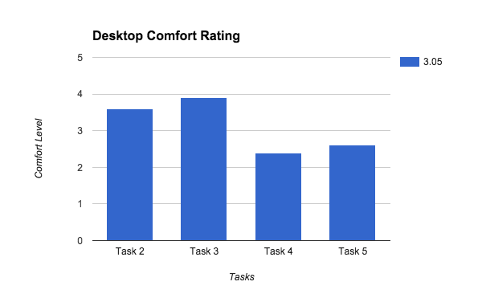

Figure 1: Comfort rating for tasks performed on the Desktop

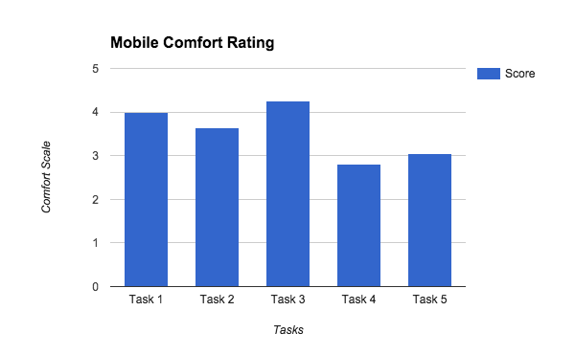

Figure 2: Comfort rating for tasks performed on the Mobile app

The graphs shows consistency for the user comfort rating for tasks performed on the mobile and on the desktop website. Five tasks were common to both the platforms. We are comparing above graphs to understand the difference in comfort level from the observations. The comfort rating scores were obtained from the “post-task questionnaires”, filled in by each participant at the end of each task. From the graphs it is clear that both the platforms are consistent since we got the identical results.

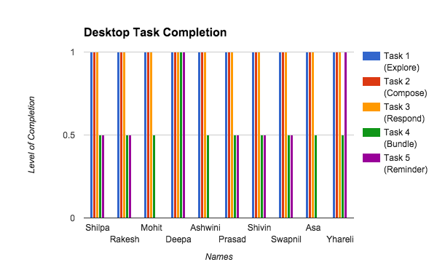

Figure 3: Graph indicating level of success (completion) for tasks performed on the desktop

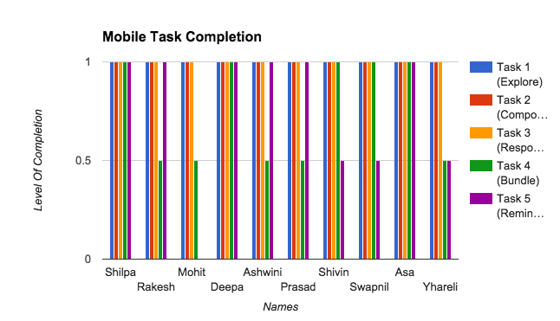

Figure 4: Graph indicating level of success (completion) for tasks performed on the mobile app.

The graphs shows inconsistency for the task completion for tasks performed on the mobile and on the desktop website. This comfort rating decide based on the observation of users how they approach and complete the task . Five tasks were common to both the platforms. We are comparing above graphs to understand the difference in task completions from the observations. The completion level scores were obtained from the by observing each participant at the throughout the task. From the graphs it is clear that mobile application is easy to use as compared to desktop platform.

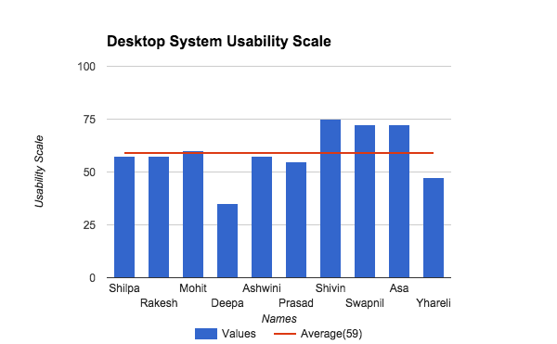

Figure 7: System usability scale - Desktop

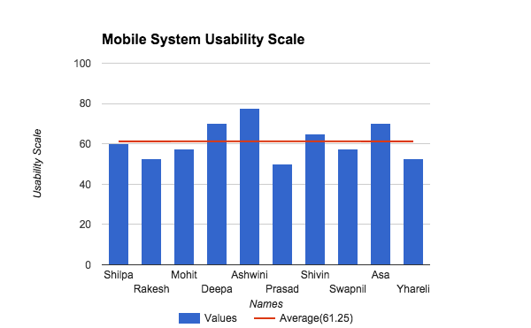

Figure 8: System usability scale - Mobile.

The graphs shows users are more comfortable with mobile platform based on system usability scale data captured for mobile and on the desktop website. After completing five common task on each platform participant asked to fill “post-interview questionnaires”, to capture the data for system usability scale. From the graphs it is clear that both the mobile application is comparatively easier to use.

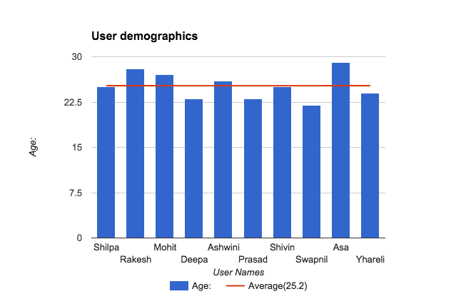

Figure 9: User Demographics

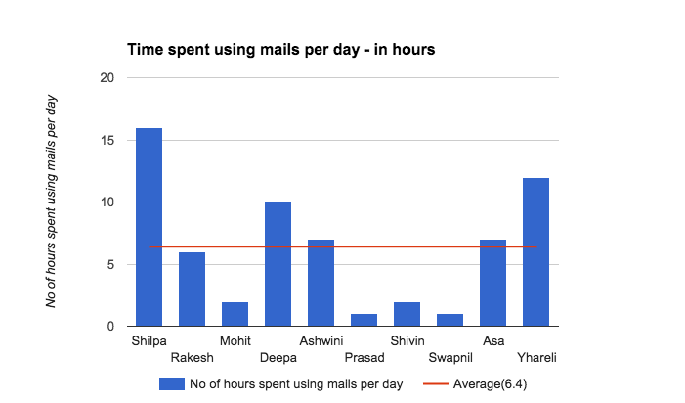

Figure 10: Time spent using email per day.

The above graphs shows that average time spent on email is 6.4 hours/day.

# **4. Conclusion**

----------------------------------------------------------------------------------------------------------------

In conclusion, our group had some great insights on implications design can have on the success or failure of any application. According to our observations, the user experience of Google Inbox on mobile was more impressive and easier for the user as compared to the Desktop version. Due to a steep learning curve, most first time users had a major problem getting through many tasks, and our recommendation for Google would be to either decrease the learning curve, or, we would like to conduct this study after the user has had his time to learn the application. Some Icons need to be polished as majority of users could not identify the functionality of the option, for example, the ‘Done’ option confused the users to a point they were clueless as to what they did wrong, what’s happening and how to undo it. The Bundling and Reminder features were extremely confusing for a first time user, but the same user showed a better understanding of the feature on the second half of the test.

We think incorporating these changes can help Google Inbox achieve its full potential and appeal to a larger audience.

# **5. Appendices**

----------------------------------------------------------------------------------------------------------------

## **5.1 System Usability Scale**

**Questionnaire**

1. I think that I would like to use this website/app frequently.
2. I found the website/app unnecessarily complex
3. I thought the website/app was easy to use.
4. I think that I would need the support of a technical person to be able to use this website/app.
5. I found the various functions in this website/app were well integrated
6. I thought there was too much inconsistency in this website/app
7. I would imagine that most people would learn to use this website/app very quickly
8. I found the website/app very cumbersome to use.
9. I felt very confident using the website/app
10. I needed to learn a lot of things before I could get going with this website/app.

## 

## **5.2 Informed Consent Form**

|  |
| --- |
| **Please read and sign this form before you proceed to the usability testing session.**  In this usability test:  • You will be asked to perform certain tasks on an existing website.  • We will also conduct a simultaneous interview with you as you interact with the website.  • The testing session will be recorded on video and your responses/comments will also be recorded on paper by one of the investigators.  • There are no substantial benefits and rewards for your participation in this test. Additionally, there are probably no risks to you.  Participation in this usability study is voluntary. All information will remain strictly confidential. The descriptions, recordings, and findings will only be shared amongst persons directly involved in this study and may be used to help improve the website/app. However, at no time will your name or any other identification be used. You can withdraw your consent to the experiment and stop participation at any time.  If you have any questions after today, please contact *<evaluator’s name> <evaluator’s email-id>*.  **I have read and understood the information on this form and had all of my questions answered.**  ______________________________ _________________  Participant's Signature Date    ________________________________ _________________  Usability Consultant’s Signature Date |

## **5.3 Usability Test Plan**

### Participant Welcome and introduction

Hi [Name], my name is [Name] and I’ll be walking you through this session today. I also have [Names] on the line, who will be taking notes and observing the session.

I want to thank you for agreeing to participate in this study. We are trying to study the experiences of users while using google Inbox desktop application and mobile app. I would like to make it clear to you that we are testing the application and not you. There isn't anything right or wrong on your part in this test. If you find anything confusing or go along a different path while performing a task, it is completely ok and we would like to know what the reason behind it was.

So do try to think aloud so we can better understand your experience. We want to see if there is anything that can be improved in the design, so it is absolutely ok for you to point out, explicitly, anything you feel isn’t normal, without any fear. If you have any questions, just ask. I may not be able to answer them immediately, as we want to observe how users would overcome their confusions. I would like to resolve any problems you faced after we’re done with the session.

For our convenience, I would ask for your permission to record our session. The recordings will only be used to avoid recollection on our side and would not revealed to anyone outside our project group.

To get started, I would like you to give us a confirmation that you agree to all our conditions by signing a consent form for us. And if you have any questions, we would like to clear them out now.

*Please hand the participant a consent form. Participant has to sign two forms, one for mobile app and second for desktop site usability testing.

### Background

* Before we get started, I’d like to ask a few questions related to you.
* Firstly, what's your occupation?
* Could you tell us, roughly, how many hours per week would you spend using internet, including emails?
* How many mail clients do you use? Including for personal and official work.
* Ok, how many of those hours would you spend on your Desktop/Laptop or mobile?
* What device do you prefer to access your mails on?
* Are you aware of the new google Inbox app launched?
* (if yes) How do you access your Inbox?
* (if no) Would you like to have a tour of the new Inbox and explore its features?
* Do you have separate mail accounts for personal, professional and other uses or you just have one account?
* (if yes)What is the purpose of maintaining separate accounts?
* (if no) What is the advantage of having single account for all purposes?

### Scenario

Ok, today we are going to look at a new feature from Google called “Inbox”. We are going to have you perform some tasks that you perform using Gmail or any other mailing application. We also want you to explore some new features provided by Inbox.

### Task List

Ok, so let’s take a look at some tasks to see if these matches your expectations

1. View your email Inbox

2. Compose an Email.

3. Respond to an Email

4. Explore the feature of grouping mails into customized category.

5. Create a customized group called ‘Family’

6. Explore the feature of setting reminders for an event in the mail

### Facilitator Script

Now I shall get your attention first to the website and ask you to perform entire usability test on this platform.Then we will move on to mobile app and ask you to perform the same usability test on mobile app platform.

* Looking at the website/mobile app, what is the first impression that you get?
* What are your first thoughts?
* What do you think you would click on first?
* For now, don’t actually click on anything. Just tell me what you would click on. And again, as much as possible, try to think out loud so we know what you’re thinking.

Ok, so let’s take a look at some tasks to see if these matches your expectations

#### View your email Inbox

* Ok, so let’s say you have logged in your Inbox and arrive at this page.
* Take a minute to look at the screen.
* What do you think about the screen?
* Does this screen look appealing to you?
* What’s different in this screen from the other mailing client screens that you use?
* Are you able to notice the new features provided by Inbox?
* Go ahead and try the new features.
* How would you rate you experience with this task on the scale of (1-5)?

#### 2. Compose an Email

* Ok, so now to compose an email, can you tell me how would you proceed?
* Go ahead and compose a simple email
* Did you find it easy or difficult to complete this task?
* What did you find confusing or appealing?
* Are there any suggestions you’d like to give for this page?
* How would you rate you experience with this task on the scale of (1-5)?

#### 3. Respond to an Email

* Ok, so now to respond to an email, can you tell me how would you proceed?
* Can you go ahead and locate the mail from [name].
* Can you locate options for responding to the mail from [name]?
* Ok, go ahead and try it.
* Did you find it easy or difficult to complete this task?
* What did you find confusing or appealing?
* Are there any suggestions you’d like to give for this page?
* How would you rate you experience with this task on the scale of (1-5)?

#### 4. Explore how to group mails into a category.

* Ok, so how do you group mails using your existing mail client?
* How is your experience with it?
* Do you see similar options for grouping in the system you are testing?
* Go ahead and group mails received from “Indeed.com” in a folder named jobs?
* How was your experience with the process?
* How would you rate this process on a scale of(1-5) in comparison to the grouping process of your existing mail client?
* Did you find the process confusing?
* (if yes) What part of the process was confusing?
* (if no) What part of the process you found appealing and why?
* Will you go ahead using this feature in future?
* (if yes) Why?
* (if no) Why?
* How would you rate you experience with this task on the scale of (1-5)?

#### 5. Create a customized category called ‘Family’

* Ok, so now just go ahead and create a customized category “Family”.
* Now, I need you to move all the family related mails to that particular group.
* Go ahead and give it a try.
* Is this what you expected to be the process like?
* Did you find the process easy or confusing?
* How would you rate you experience with this task on the scale of (1-5)?

#### Explore how to set reminder for an event

* Go ahead and try setting reminder for an event you wanted to be reminded of.
* How was your experience with the process of setting reminders?
* Was it what you expected it to be?
* Is there a way to snooze your reminder for later time from here
* Go ahead and try it out.
* Is this what you expected it to be?
* How would you rate you experience with this task on the scale of (1-5)?

### 

### 5.4 Interview sessions

All the recordings and observation notes for the usability sessions can be found at the following google drive link.

<https://drive.google.com/folderview?id=0BzjBhDzTls_3Q1NFSG82ZUs1V2c&usp=sharing>